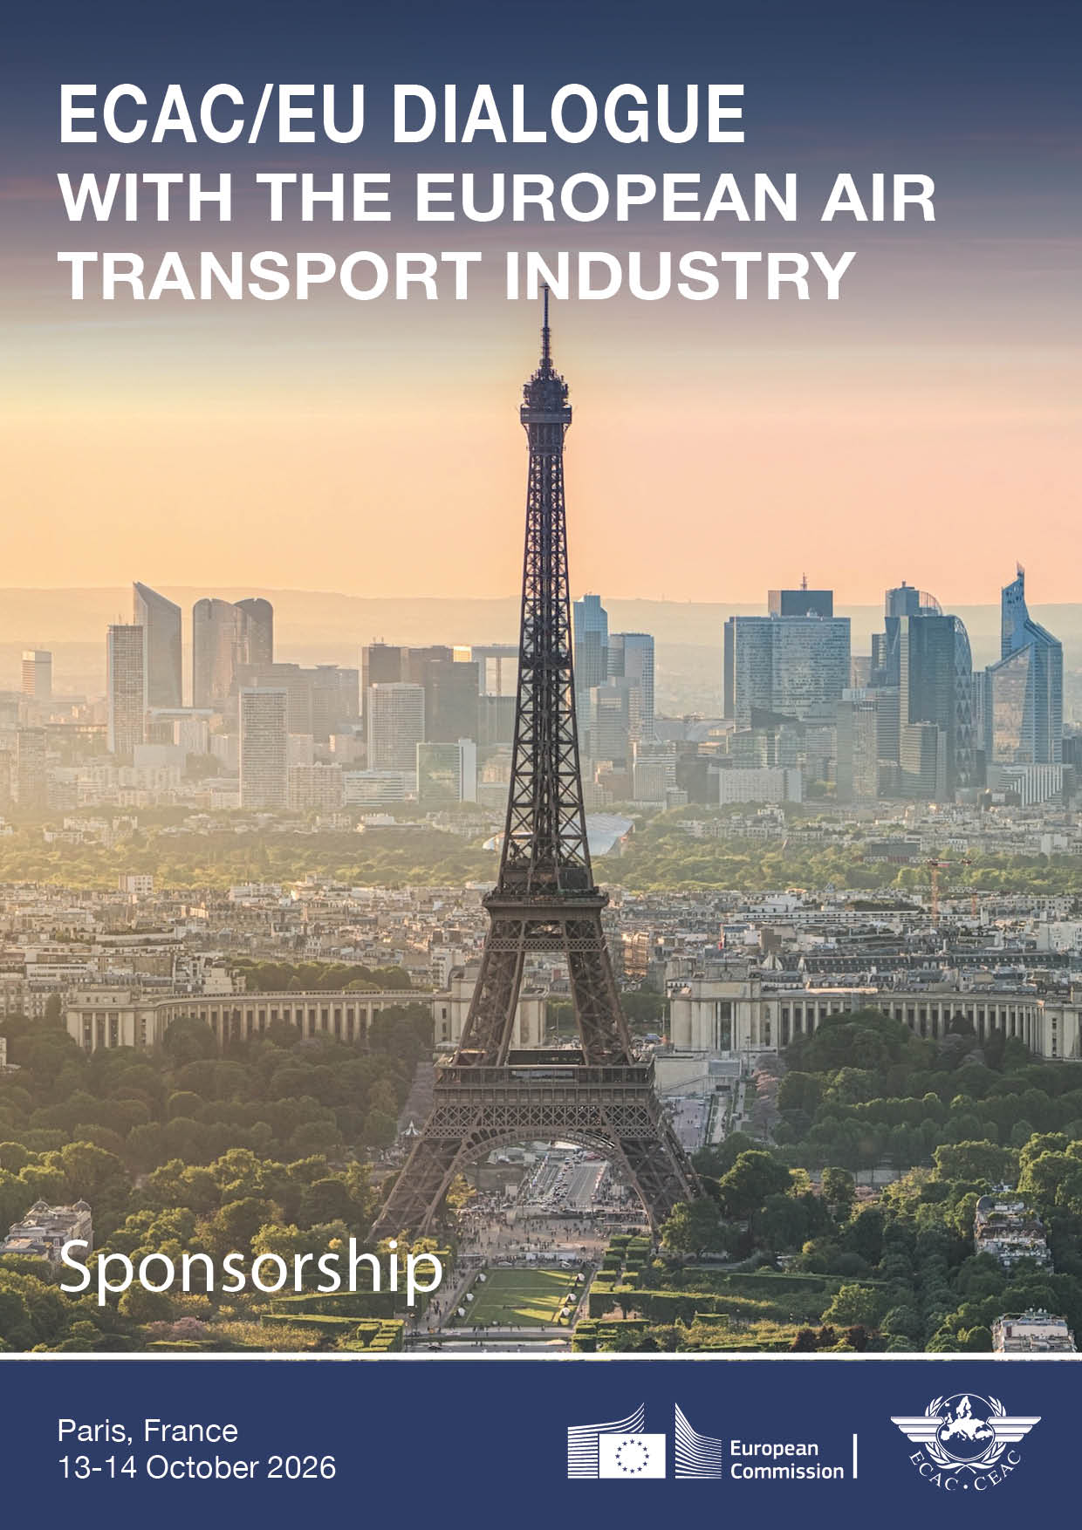

ECAC/EU DIALOGUE
with the European air transport industry
Is resilience successfully engrained in aviation, or are we failing to adequately adapt?
Paris | 13-14 October 2026

Sponsorship information
The ECAC/EU Dialogue with the European air transport industry offers a valuable opportunity to bring your business to the attention of senior European and international leaders from across the aviation sector.
The event offers direct access to high-level decision-makers, with opportunities to connect during conference sessions as well as dedicated networking and social events.
If your organisation is interested in becoming a sponsor, please complete the attached form or contact gcaw@ecac-ceac.org.
Visit the conference website for more information on the event and to view the programme.

Why sponsor?
- Increase your visibility: Position your organisation among senior representatives of European institutions, national authorities, and industry leaders from across ECAC’s 44 Member States.
- Engage with decision-makers: Build valuable connections with regulators, policymakers and aviation executives through targeted networking opportunities.
- Showcase your expertise: Present your products, services and innovations to a high-level audience from both the public and private sectors.
- Align with a strategic initiative: Strengthen your profile through association with a leading European aviation forum jointly organised by ECAC and the European Commission.

Examples of sponsorship opportunities
Event | Sponsor category | Date
Welcome cocktail | Gold/Platinum | 12 October
Morning refreshments | Bronze | 13 October
Lunch | Silver | 13 October
Mid-afternoon refreshments | Bronze | 13 October
Standing cocktail reception | Gold/Platinum | 13 October
Morning refreshments | Bronze | 14 October

Additional sponsorship opportunities are available, and packages can be tailored to suit your needs. Please contact us for more information: gcaw@ecac-ceac.org.
Sponsorship levels:
Bronze: up to and including €3000
Silver: over €3000 and up to and including €8000
Gold: over €8000 and up to and including €15 000
Platinum: over €15 000

Sponsorship benefits | Bronze | Silver | Gold | Platinum
Logo and link on conference website
Logo displayed on screen in the meeting room
Logo included in promotional material
Invitations to social events
Networking opportunities
Complimentary delegate entrance | 2 | 3 | 4 | 5
Distribution of promotional material
Logo on conference programme
Small exhibit table
Prominent logo placement (website and programme)
Logo projection during key conference moments (such as session breaks)
Small exhibit table in a high-visibility area
Branding on cocktail menus (if sponsoring event)
Audience-relevant video projection during session breaks (non-speaking opportunity)

Contact
For further information on sponsorship rates and opportunities, please contact the ECAC Secretariat (gcaw@ecac-ceac.org).

_______

ECAC/EU DIALOGUE
with the European air transport industry
Is resilience successfully engrained in aviation, or are we failing to adequately adapt?
Paris | 13-14 October 2026

SPONSORSHIP FORM

1. Sponsor details
Company name:
Contact person:
Job title:
Email:
Telephone number:
Postal address:
Company website:

2. Sponsorship package
☐ Bronze: up to and including €3000
☐ Silver: over €3000 and up to and including €8000
☐ Gold: over €8000 and up to and including €15 000
☐ Platinum: over €15 000
Sponsorship amount (EUR):

3. Billing information
Billing contact name:
Billing email:
Billing address:
Company website:
Purchase order/reference (if applicable):

4. Sponsorship information for event material
Please send your company logo (300 dpi resolution) via email in one of the following formats: jpeg, tif, png or eps

Organisation name as it should appear:
Contact person for coordination (if different):
Email:
Website:

5. Payment terms
Upon receipt of the duly completed sponsorship form, ECAC will issue an invoice for the applicable sponsorship fee and send it by email to the sponsor. Payment is requested within 20 days of receipt of the invoice and should be made by bank transfer in Euros.
Note: The organisers will arrange the hospitality events and will settle the bill with the recommended service provider.

6. Confirmation
By submitting this form, the sponsor confirms its intention to provide sponsorship for the ECAC/EU Dialogue in accordance with the details indicated above.
Name: Position:
Signature: Date:

7. Return the form
Please send the completed sponsorship form by email to:

ECAC Secretariat
Email: gcaw@ecac-ceac.org and secretariat@ecac-ceac.org

Thank you.

